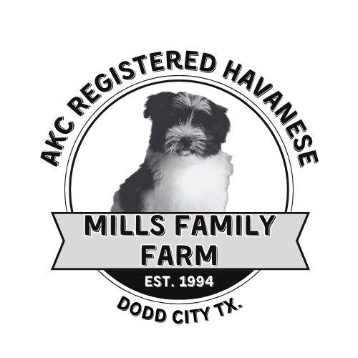
Mills Family Farm Kennel
2487 CR 2900
Dodd City Texas 75438 903.640.3805
Breed: Havanese Dog Identified As: Sex: DOB:
Buyer Name DATE:
THIS IS A CONTRACT BETWEEN BUYER AND SELLER. THE SELLER GUARANTEES THIS DOG TO BE IN GOOD HEALTH AT THE TIME OF DELIVERY.
REPLACEMENT OF THE DOG WILL BE BASED UPON AVAILABILITY UNDER THE FOLLOWING CONDITIONS:
1. THE DOG IS DECLARED TO HAVE A LIFE THREATENING CONDITION BY A LICENSED VETERINARIAN WITHIN 4 DAYS OF PURCHASE AND RETURNED TO THE SELLER WITH A WRITTEN REPORT BY THE VET ADDRESSED TO MILLS FAMILY FARM KENNELS. 2. IF DOG DIES, YOU MUST HAVE FOLLOWED ALL THE ADVICE BY THE VET AND AN AUTOPSY PERFORMED BY A STATE LAB AND PROVIDE THE SELLER WITH A COPY OF THE STATE REPORT.
THE SELLER DOES NOT GUARANTEE AGAINST MINOR CONDITIONS HOWEVER THE DOGS HAVE BEEN MEDICATED FOR PREVENTION OF WORMS AND HAS RECIEVED THEIR FIRST ROUND OF SHOTS AND HAD A WELL CHECK BY A VETERINARIAN. THE SELLER WILL NOT ASSUME ANY EXPENSES INCURRED BY THE BUYER FOR SUCH.
ALL PUPPIES ARE SOLD AS PETS ONLY. NO GUARANTEE OF SHOWING ABILITY.
NO GUARANTEE WILL BE GIVEN TO SIZE, COLOR, OR FERTILITY
IF THE OWNER NO LONGER WANTS THE PUPPY, THE PUPPY CAN BE RETURNED TO THE SELLER ANY TIME WITH NO COST TO THE SELLER BUT NO MONETARY REFUNDS ARE GIVEN.
I, THE BUYER HAVE READ THESE TERMS AND I UNDERSTAND THEM AND AGREE AS ATTESTED BY MY SIGNATURE BELOW.
THIS CONTRACT IS UNDER THE JURISDICTION OF THE STATE OF TEXAS, IN FANNIN COUNTY BUYER:
PHONE: ______________ ADDRESS: __________________________
EMAIL: ____________________________ __________________________
___I will pay in full $2500 in cash upon pick up or I will pay in full via cash app or venmo
__I will pay the $300 nonrefundable deposit to reserve my puppy and pay the remaining $2200 at the time of pickup.
______________________________________________________________BUYER SIGNATURE
Teresa Mills SELLER SIGNATURE

